DENTURES

Introduction

Whether you have worn dentures for some time or are about to wear them for the first time, you probably have many questions.

Dentures in one form or another have been around for many years. The earliest recorded use of dentures was more than 2000 years ago. Today, dentures are better quality and more comfortable than ever before.

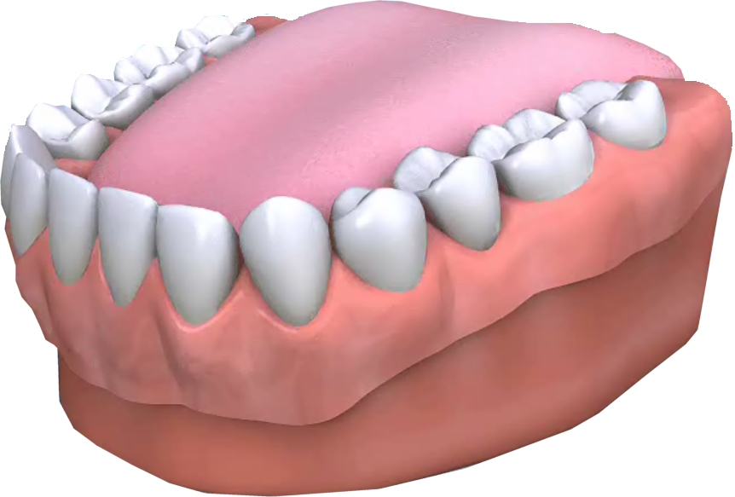

Q Why bother with dentures?

A Replacing lost or missing teeth has substantial benefits for your health and appearance. A complete or full denture replaces the natural teeth and provides support for cheeks and lips. Without this support, sagging facial muscles can make a person appear older and reduce their ability to eat and speak.

Q What is a denture?

A A denture is an appliance which is worn to replace lost or missing teeth to enable you to enjoy a healthy diet and smile with confidence.

A complete or full denture is one that replaces all of the natural teeth in either the upper or lower jaws.

A partial denture fills in the spaces created by lost or missing teeth and is attached to your natural teeth with metal clasps or devices called precision attachments.

Q What are dentures made of?

A The base of a denture is called a plate and can be made of either acrylic (plastic) or metal. The teeth are normally made of acrylic and can be made to match your natural teeth. This is especially important in the case of partial dentures.

Q Will dentures make me look different?

A Dentures can be made to closely resemble your natural teeth so that little change in appearance will be noticeable. Modern dentures may even improve the look of your smile and help fill out the appearance of your face.

Q Will I be able to eat with dentures?

A Eating will take a little practice. Start with soft foods cut into small pieces. Chew slowly using both sides of your mouth at the same time to prevent the denture from moving. As you become more used to your denture, add other foods until you return to your normal healthy diet.

Q Will dentures change how I speak?

A Pronouncing certain words may require practice. Reading out loud and repeating difficult words will help. Over time you will adjust and get used to it, so don’t worry!

If you find that your dentures occasionally slip when you laugh, cough or smile, reposition the denture by gently biting down and swallowing. If this continues consult your dentist.

Q Will my sense of taste be affected?

A This is quite a common worry, but the fact is that your teeth have nothing to do with your sense of taste. Your taste buds are mainly on your tongue and they will still be there so eventually everything will not taste too different. However, at first food may not taste the same, as your dentures will interfere with your taste buds while your mouth adjusts to the feel of the denture. Your ability to sense hot food and drink may also be affected, so for a while it is a good idea to avoid very hot food and drinks, as you may burn yourself.

Q How long should I wear my dentures?

A During the first few days, you may be advised to wear them for most of the time, including while you are asleep. This will allow you to adjust to your new dentures and let them settle in. After an initial period of adjustment your dentist may advise that you remove them before going to bed. This allows your gums to rest and helps promote oral health. If you decide to keep them in overnight, it is important that you clean them thoroughly before you go to bed, just as you would natural teeth.

Q Must I do anything special to care for my mouth?

A Even with full dentures, you still need to take good care of your mouth. Every morning and evening, brush your gums, tongue and palate (roof of your mouth) with a soft –bristled brush. This removes plaque and stimulates circulation in the mouth. It is vitally important that partial denture wearers brush their teeth thoroughly every day to prevent tooth decay and gum disease that can lead to further teeth being lost.

Q What is the difference between conventional and Immediate Dentures?

A Conventional dentures are made and inserted after teeth have been removed and the tissues have healed. Healing may take several months.

Immediate Dentures are inserted immediately after teeth have been removed. To do this, the dentist takes measurements and impressions of your mouth during a preliminary visit

An advantage of Immediate Dentures is that the wearer does not have to be without teeth during the healing period. However, bone and gums can shrink over time, especially during the first six months after teeth have been removed. When gums shrink, Immediate Dentures may require relining or even replacing to fit properly.

Q What will dentures feel like?

A New dentures may feel awkward or even uncomfortable for a few weeks until you become accustomed to them. The dentures may feel loose while the muscles of your cheek and tongue learn to keep them in place. Should this continue, consult your dentist.

It is not unusual to experience minor irritation or soreness during this period. You may also find that saliva flow temporarily increases. As your mouth becomes accustomed to the dentures, these problems should diminish. If any problems persist, particularly irritation or soreness, be sure to consult your dentist as soon as possible and not wait for your regular check up. Do not take your dentures out though, leave them in, that way the dentist will be able to see where it is sore and sort the problem out quicker.

Q How do I take care of my dentures?

A Dentures are very delicate and may break if dropped. When cleaning dentures it is recommended that you do so over a folded towel or sink of water. When you are not wearing your dentures, they should be stored in a container containing enough water to cover them.

Like natural teeth, dentures must be brushed daily to remove food debris and plaque. Brushing helps prevent dentures becoming stained and helps your mouth stay healthy. There are special denture cleaning brushes available but a soft bristled toothbrush can also be used. Avoid using hard-bristled brushes, which can cause damage.

The use of an effervescent denture cleaner will help remove stubborn stains and leave your denture feeling fresher.

Q Can dentures be re-polished?

A Yes they can. After considerable use, dentures can become slightly dull and rough. However, if you take them back to your dentist, they can be re-polished and restored to their original appearance.

Q Will my dentures need to be replaced?

A Over a period of time, dentures will need to be relined or re-made due to normal wear or a change in the shape of your mouth. Bone and gum ridges can recede or shrink causing jaws to align differently. Loose dentures can cause health problems, including sores and infections not to mention discomfort. A loose or ill-fitting denture can also make eating and speaking more difficult. It is important to replace worn or poorly fitting dentures before they cause problems.

Q How often should I see my dentist?

A Regular dental check-ups and having your teeth professionally cleaned are vital for maintaining healthy teeth and gums, most dentists recommend that under normal circumstances this should be done every 6 months. Full denture wearers should consult their dentist as to frequency of visits.

With regular professional care, a positive attitude and persistence, you can become one of the millions of people who wear their dentures with a smile.

