APICECTOMY

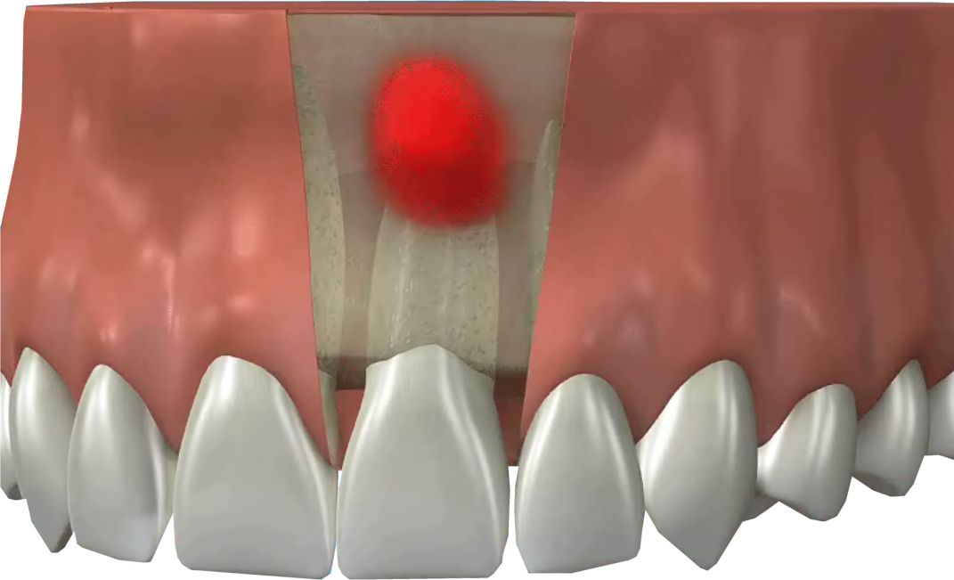

Q What is an Apicectomy?

A An Apicectomy is the removal of a small part of the end of a root, as well as the abscess infection in the bone.

Q Why is an Apicectomy needed?

A An Apicectomy is required to clean out the infection at the end of the root and bone.

Q Does it hurt?

A No. A local anaesthetic is used.

Q What does it involve?

A The aim of the treatment is to remove infection from the base of the root of the tooth. The root is then cleaned and filled to prevent any further infection.

About 3 – 4mm is removed from the root tip. This has two functions. The first is to remove the infected part and the second to facilitate the filling and healing of the root end.

Q What will my tooth look like after treatment?

A Your tooth will look the same as before the treatment.

Q What if it happens again?

A If the infection recurs you will need to discuss the future of the tooth with your dentist. Sometimes
there is a small crack in the root which means it cannot be saved.

Q Is it expensive?

A The treatment is not expensive.

Q What if I don’t have the treatment?

A The alternative is to have the tooth out. Although some people would prefer an extraction, it is usually best to keep as many natural teeth as possible.

Q Where can this treatment be carried out?

A Either your dentist or an oral surgeon can carry out this treatment.

Q What about aftercare?

A You should use a mouthwash containing chlohexidine which is anti-plaque. You will also need to brush gently to avoid damaging the sutures.

