FIXED BRACE (TrainTrack)

Q What is my brace made up of?

A Your brace is made up of small brackets glued to your teeth. The brackets are handles used to hold your teeth and straighten them; the archwire, which runs through the brackets moves the teeth. We start with the most gentle archwire and gradually move up through five sizes. The archwire is held in place by tiny elastic bands, which come in different colours.

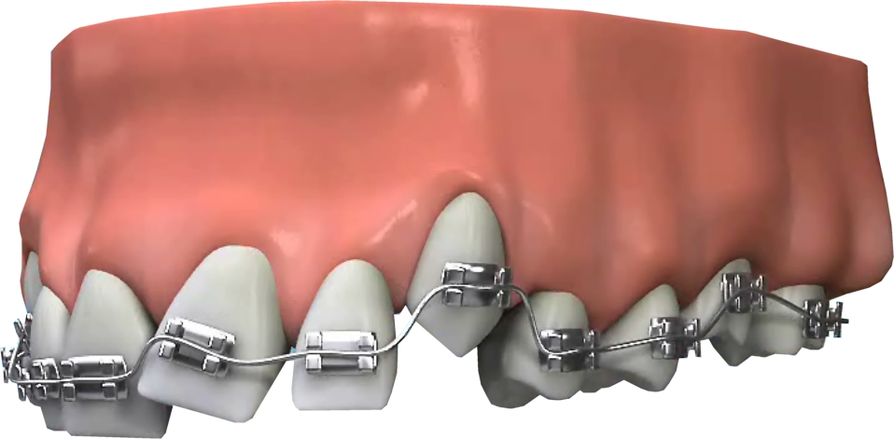
Q Will it hurt?

A It is usual for the teeth to be uncomfortable for the first few days after the brace is first fitted - stay with a soft diet and if necessary take one or two tablets of paracetamol or ibuprofen.

Q What if bits break off?

A If one bracket comes off then leave it until your next scheduled visit. If several break off then phone for an appointment to have the brace repaired.

Often as the teeth move the archwire sticks out at the back. If this scratches your cheek come in to have the end cut off (ask reception for a packet of wax in case this happens).

Q How do I clean my teeth?

A Since the brace is fixed you cannot remove it for brushing. It is extremely important to spend extra time brushing all around the brace and especially the gums. If the dirt builds up then your gums will bleed a lot (gingivitis) and your teeth will decay. Special brushes and fluoride mouthwashes for daily use can usually be obtained from the receptionist of your dental surgery

Q Will there be marks on my teeth when the brace comes off?

A Poor cleaning and too many fizzy drinks can cause permanent decay marks. The importance of thorough brushing and the use of a fluoride mouthwash cannot be emphasised enough.

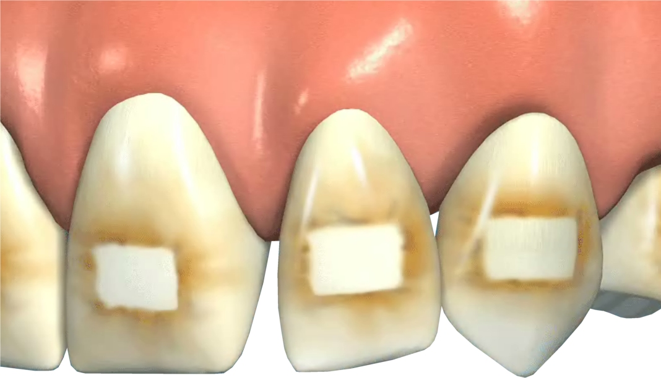
Q What about sports?

A Contact sports such as rugby present a problem since it is difficult to make a gum shield that will fit over the brace. A reasonable solution is to buy a cheap gumshield from a sports shop which can be softened in hot water and moulded over the brace.

Q How long before the brace is removed?

A It usually takes about 18 months, occasionally longer, to straighten your teeth. "Traintrack" braces are very good at straightening teeth so that they look better in months. It is important to remember, however, that if the brace is removed too quickly before the teeth have settled into their new positions, then the teeth tend to go crooked again.

Q So how are the teeth kept straight after the fixed brace is removed?

A Usually we make a removable brace called a retainer to wear at nights for at least 12 months. Sometimes a wire is fixed to the insides of the teeth to hold them straight.

